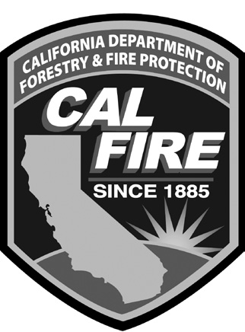
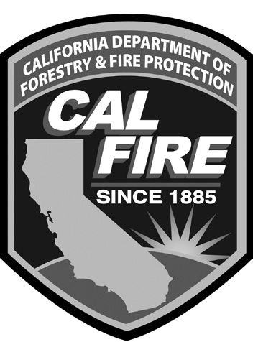

CALIFORNIA DEPARTMENT OF FORESTRY AND FIRE PROTECTION Substitute Training

Description Description Description

NWCG ICS Courses State Fire Marshal - Level One NWCG Skills Courses

Dozer Boss | Command 1A | Cause & Origin
Basic ICS | Command 1B | Look Up/Down/Around
Staging Area Manager | Command 1C | Class A Foam
Field Observer | Training Instructor 1A | Urban Interface
Check In/Status Recorder | Training Instructor 1B | Portable Pumps/H2O Use
Ordering Manager | Investigation 1A | Power Saws
Receiving and Distribution Manager | Investigation 1B | HazMat Drug Lab ID
Personnel/Equipment Time Recorder | Management
Tool and Equipment Manager | Fire Prevention 1A
Helispot Manager | Fire Prevention 1B
Medical Unit Leader | Fire Prevention 1C | National Fire Academy
Ground Support Unit Leader | Public Education
 | HazMat 1A | Firefighter Health & Safety
 | HazMat 1B | Firefighter Safety and Survival
 | HazMat 1C | Response to Terrorism
 | HazMat 1D | Hazmat Incident Analysis
 | HazMat 1F
State Fire Marshal-FSTEP Courses | Hazmat 1G
 | Rescue Systems 1 | CFFJAC
Fire Control 1 Rescue Systems 2 Terrorism Consequence Management
Fire Control 2
Fire Control 3 A/B
Fire Control 4 A/B
Fire Control 5 (SFM classes: must take level 1 before next in series)
Fire Control 6
Fire Control 7
Confined Space Awareness Low Angle Rescue Emergency Resp. Elec. Veh.
Pipeline Safety
Trench Rescue
River & Flood H2O Rescue

CALIFORNIA DEPARTMENT OF FORESTRY AND FIRE PROTECTION
Apprentice Heavy Fire Equipment Operator
Training Codes

Code | First Year Syllabus  Description | Code | Second Year Syllabus  Description | Code | Third Year Syllabus  Description
LSAD | Incident Management I | FFAA | Compliance Inspection | HJCC | Heavy Equipment Field Operations
LHCA | Basic Firing | RCAB | I-300 | SUAA | C-234 Intermediate Firing
JKFH | Soils Recognition | BBFA | Fire Prevention/Investigation | JIBC | Supervision II
LTFA | Wildland Firefighter Safety & Survival | HJCB | Heavy Equipment Field Operations | KAAG | Training Instructor 1C
HJCA | Heavy Equipment Field Operations | LUAB | Suppression Tactics | GBAA | Fire Mechanics Basic Electrical
LTAA | Review Dozer Incidents | SNAA | S-212 | LSAE | Incident Management II
LUCA | Dozer Strategy & Tactics | LTAB | Review Dozer Incidents
JLAA | Working with Inmates | LTAC | Wildland Firefighter Safety & Survival
JLAB | Swamper Proficiency Standards | LUCB | Dozer Strategy & Tactics
KAAE | Training Instructor 1A | HDAA | Fire Pump and Accessories
HJAA | Air Brakes | KAAF | Training Instructor 1B
LUAA | Fire Suppression Repair & Workshop | KBAA | Ethical Leadership in the Classroom
MDAA | CAL Card Purchaser | DBAD | Swift Water Awareness
TXAA | ICS Equipment Manager | HEEC | Hydraulics and Pump Operations

COLLEGE TRAINING - When training is taken at or sponsored by a college, the third letter of the JAC Code must be changed to the letter "G".
Example: The code for Training Instructor 1B (KAAF) taken at a college would be KAGF.

