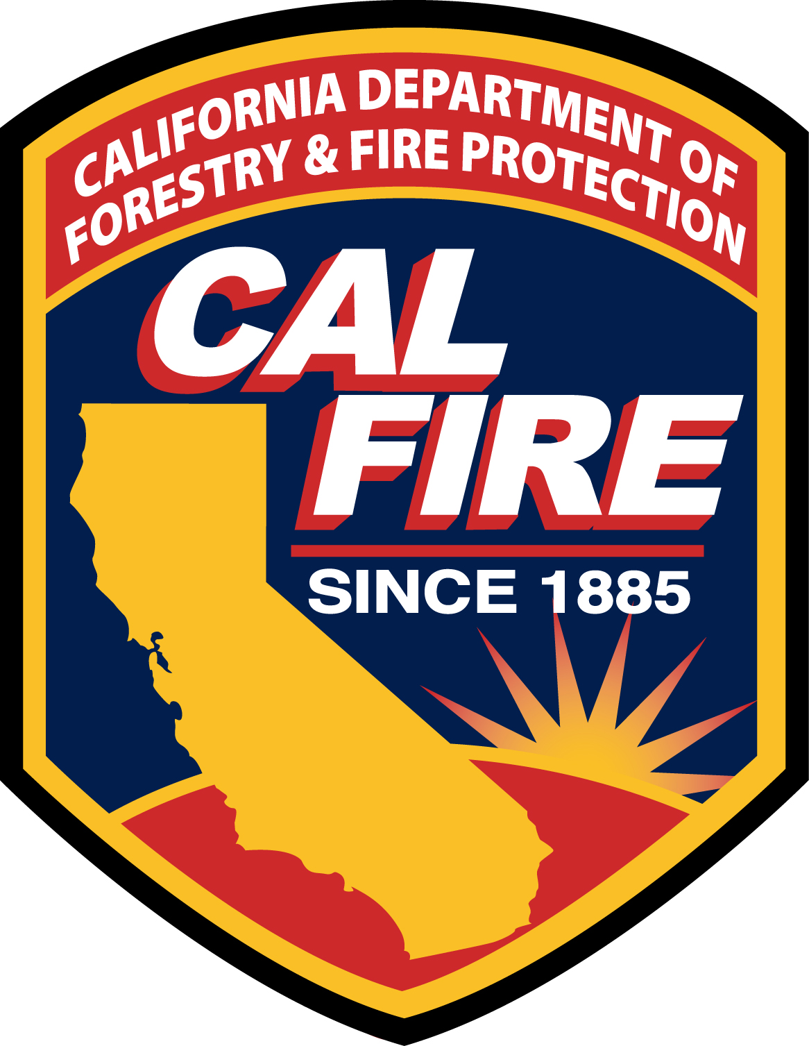
CAL FIRE Interdisciplinary Trainer Application

Application for
Discipline
Course/Working Group/Subject ___________

APPLICANT INFORMATION

Name Position/Rank
Present Assignment Work Address
City State CA Zip Business Phone
Length of service in grade Length of service with CAL FIRE Email
Certifications/Licenses

EDUCATION
Highest degree obtained College/University
Major Certificates
California teaching credential: Yes No Type
Training Instructor 1A: Yes No 1B: Yes No 1C: Yes No Other
Training Instructor 2A: Yes No 2B: Yes No 2C: Yes No Other
UC-60-hour Instructor course: Yes No M-410 Facilitative Instructor: Yes No Other

I have completed (check all that apply) IS-700 IS-800 IS-701 ICS-100 ICS-200 ICS-300 ICS-400
Other pertinent education and prerequisites:

NOTE: Attach All Instructor Training, Education, and Qualification Certificates and resume

EXPERIENCE
Courses taught (CAL FIRE/SFT/NWCG, etc.) or committees/working groups participated on | Course length or dates of membership | # of times course taught | Where
Specialized experience/training relative to teaching/instructing:
Qualified or certified to instruct in what subject areas and certifying authority:
Curriculum development experience:

APPLICANT SIGNATURE_________________________________________ Date____________
SUPERVISOR SIGNATURE _______________________________________ Date____________
UNIT TRAINING OFFICER SIGNATURE _____________________________ Date____________
UNIT CHIEF SIGNATURE _________________________________________ Date____________
REGION TRAINING CHIEF SIGNATURE_____________________________ Date____________
LEAD INSTRUCTOR /CHAIR SIGNATURE____________________________ Date____________
COURSE/PROGRAM COORDINATOR SIGNATURE ____________________ Date____________

ADMINISTRATIVE USE ONLY

Disposition: Approved for __________________ Denied
Applicant Notified by: ___________________________ Date _______________
Comments:_______________________________________________________________________

