
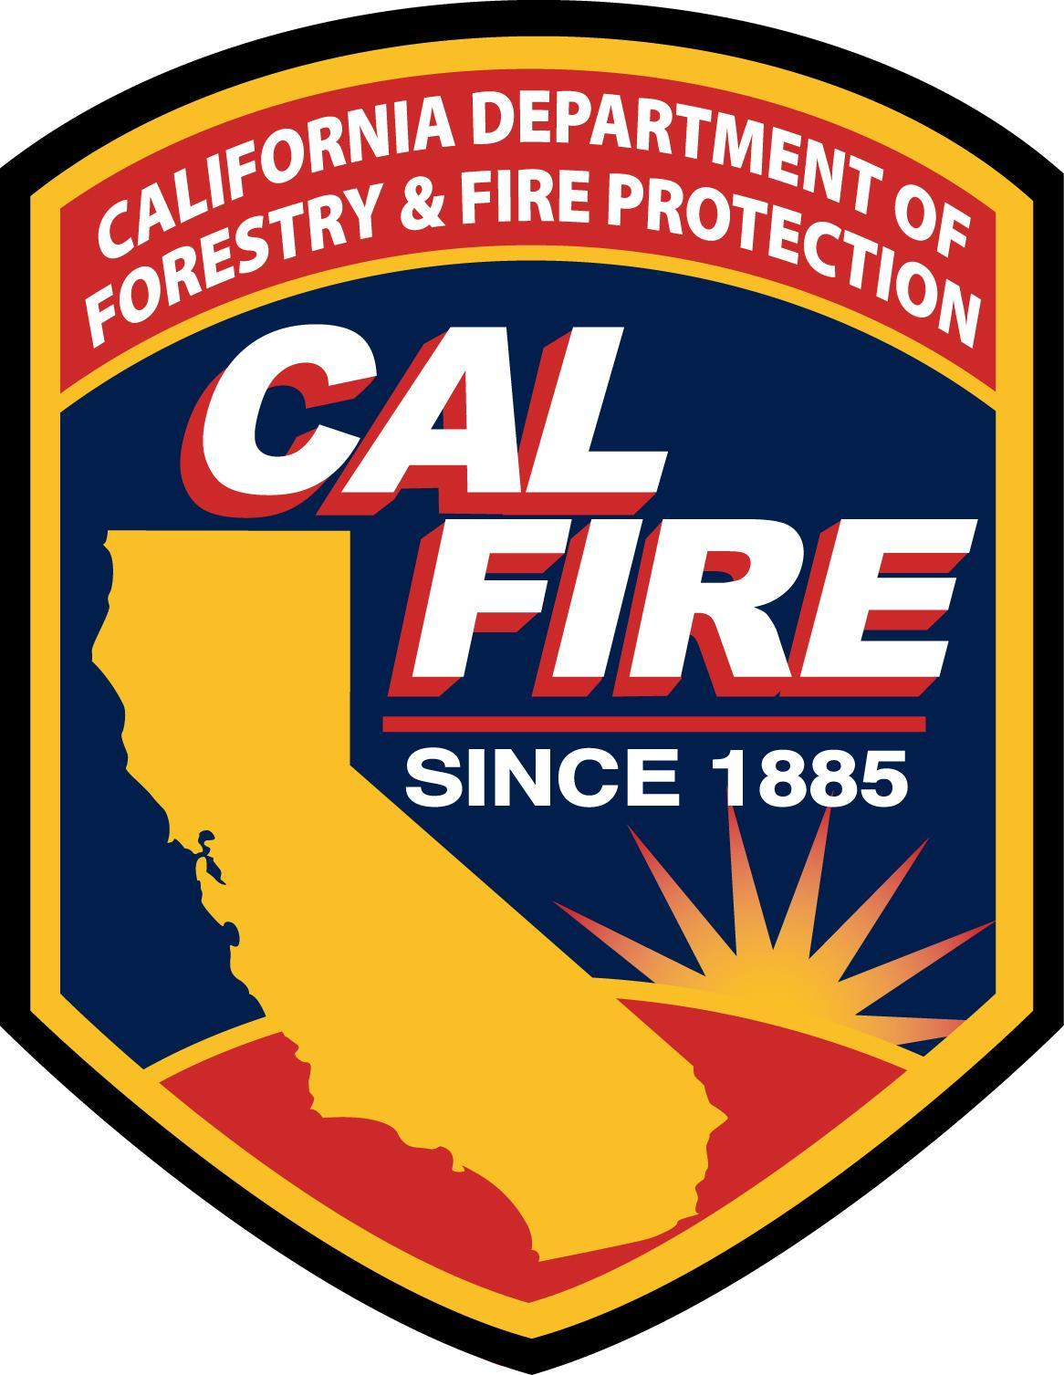
FSTEP Courses
Request for Course Scheduling
All requests must be received 6 weeks prior to the class start date.
By submitting this request, instructors and sponsoring agencies agree to comply with all published
State Fire Training policies and procedures of the California State Fire Marshal’s Office.
Email: SFT.CourseScheduler@fire.ca.gov ∗ Ph. (916) 324-6359
Today's Date: | Course: |  |  |  | Class Code: (SFT Use Only)
Start Date: | End Date: |  | Advertise In Class Schedule? Yes No
Training Facility:
Sponsoring Agency: |  |  | Class Location (City):
Contact Name: |  |  | Contact’s Phone Number: |  | Contact’s Email Address:
Primary Instructor: |  |  | Instructor Code: (SFT Use Only)
Instructor’s Phone Number: |  |  | Instructor’s Email Address:
Senior Instructor (when required): |  |  | Senior Instructor Code: (SFT Use Only)
Senior Instructor’s Phone Number: |  |  | Senior Instructor’s Email Address:
Estimated # of Students: |  | Shift Schedule?  Yes No | # of Shifts: | # of Students per Shift: |  | # of Student Manuals:
SHIPPING INFORMATION: |  |  | BILLING INFORMATION:
Ship To Agency: |  |  | Bill To Agency:
Attn: |  |  | Attn:
Street Address:  (No PO Box) |  |  | Street Address:
City/State/Zip Code: |  |  | City/State/Zip Code:
FOR STATE FIRE TRAINING USE ONLY
SFT Books: □ Download □ N/A □ Shipped ___________ Books |  |  | Shipped: □ FedEx □ Pick-up date:________
Date Shipped: | Date Returned: |  | □ MRT #: (CAL FIRE Only)
Registration and Materials |  |  | Unit Price | Quantity | Total Price
Course Registration (59210-142500-21) |  |  | $20.00 |  | $
Course Manuals (59210-141200-______) |  |  | $ |  | $
Course Manuals Sales Tax |  |  | Tax Rate: % |  | $
Shipping/Handling Charges: |  |  |  |  | $ 8.00
revised: May 2013 |  | TOTAL DUE: |  |  | $
DO NOT PAY - THIS IS NOT A BILL

Return all class materials to SFT Bookstore, 1131 S Street, Sacramento, 95811
within 15 days of the class end date & use a carrier that can track your shipment.

