
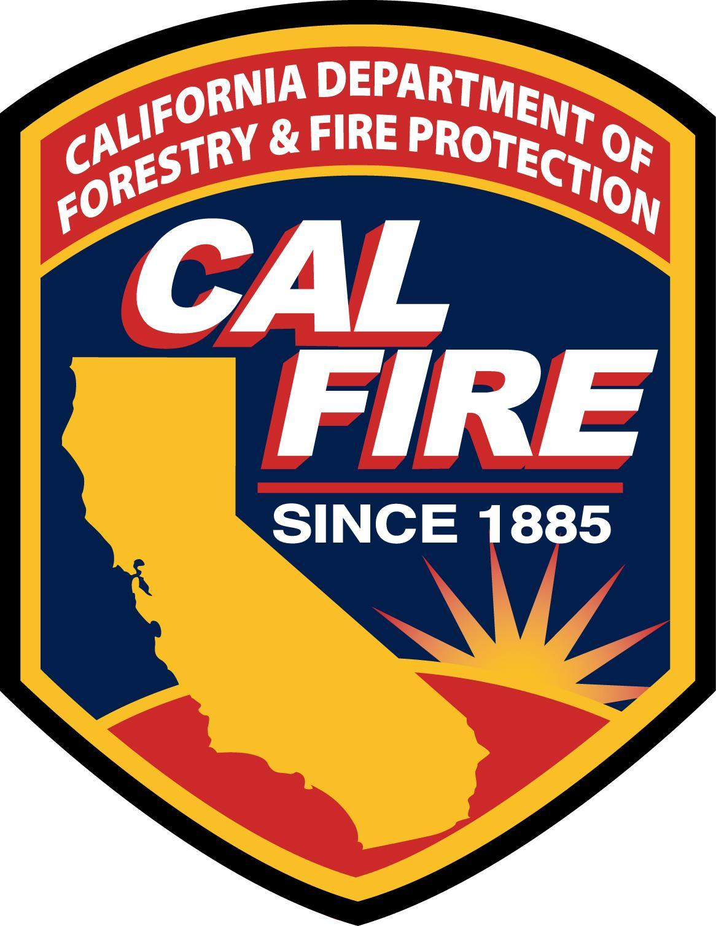
FIRE CONTROL 3A/3B
Request for Course Scheduling
PO Box 944246 ∗ Sacramento CA 94244-2460 ∗ FAX (916) 552-9464 * www.fire.ca.gov
By submitting this request, instructors and sponsoring agencies agree to comply with all published
State Fire Training policies and procedures of the California State Fire Marshal’s Office.
All requests must be received 6 weeks prior to the class start date.
Today's Date: | Fire Control 3A Fire Control 3B |  | Class Code: (SFT Use Only)
Start Date: | End Date: | Advertise In Class Schedule? Yes No
Training Facility: |  | Acquired Structure Address (complete):
Sponsoring Agency: |  | Live-fire Simulator Address (complete):
Contact Name: |  | Contact’s Phone Number: | Contact’s Email Address:
Primary Coordinator: |  | Primary Coordinator Code: (SFT Use Only)
Primary Coordinator’s Phone Number: |  | Primary Coordinator's Email Address:
Senior Coordinator: |  | Senior Coordinator Code: (SFT Use Only)
Senior Coordinator’s Phone Number: |  | Senior Coordinator's Email Address:
Estimated Number of Students: |  | SFT Use Only
SHIPPING INFORMATION: |  | BILLING INFORMATION:
Ship To Agency: |  | Bill To Agency:
Attn: |  | Attn:
Street Address:  (No PO Box) |  | Street Address:
City/State/Zip Code: |  | City/State/Zip Code:
FOR STATE FIRE TRAINING USE ONLY
Date Shipped: | Date Returned: | □ MRT #: (CDF Use Only)
Registration and Materials |  | Unit Price | Quantity | Total Price
Course Registration (59210-142500-21) |  | $20.00 |  | $
Shipping/Handling Charges: |  |  |  | $ 8.00
TOTAL DUE: |  |  |  | $
DO NOT PAY - THIS IS NOT A BILL
Scheduling Desk (916) 445-8132 Scheduling Fax (916) 552-9464
July 2009

Return all class materials to SFT Bookstore, 1131 S Street, Sacramento, 95811 within
15 days after the ending date of the class using a carrier that can track your shipment.

