Drive Test Information
There must be at least 15 days and 12 Hrs. of training between the date of getting your Commercials Learning Permit (CLP) and the date of the driving exam

Your CLP is required to have all the endorsements/restrictions listed for the type of vehicle you intend to operate. Airbrakes, Tanks (N), Hazmat….ETC

Your CA Commercial Drivers License (CDL) will be restricted to an automatic transmission (E) unless you test in a manual transmission vehicle

The vehicle you are testing in must have minimum GVWR of 26,001 lbs to meet the commercial requirements

For the drive test you will be required to provide a test vehicle of appropriate class. The test vehicle needs to be at the intersection of Hicks Lane and Airport Service Road (across from Caballo Way) before the scheduled time. You will also be responsible for the return of the vehicle to its home location.

DOCUMENTATION REQUIRED FOR SETTING UP THE DRIVE TEST
The documentation below needs to be submitted before the proctor can schedule a test:

- BTU DMV Drivers LOG with a minimum of 4 hours of pre-trip training and 8 hours of behind the wheel training
- Copy of a valid CA DMV Commercial Learners Permit (CLP) (You must keep the original on you)
- Valid certificate of completion for DGS Defensive Driver Training Program
- DMV Drive Test Questionnaire
- Copy of your Medical Certificate (According to Federal Motor Carrier Safety Administration you still have to carry a copy obtained from your doctor NOT DMV)

** All documentation needs to be electronically emailed to both:
Brian Churchill- bchurchill3737@gmail.com
Patrick Purvis- Patrick.Purvis@fire.ca.gov

Additional information:
The test will take about 3-4 hours to complete

There are no facilities at the test site, it is recommended that you have another “chase” vehicle available for logistical needs and personnel transportation.

After completing and successfully passing the Drive Test, you will need to take the completed DL 170 form (That I give you) to an authorized DMV field office. The 2 closest are:

Yuba City: 1570 Poole Blvd.
Redding: 2135 Civic Center Dr.

Test Site Location Map:

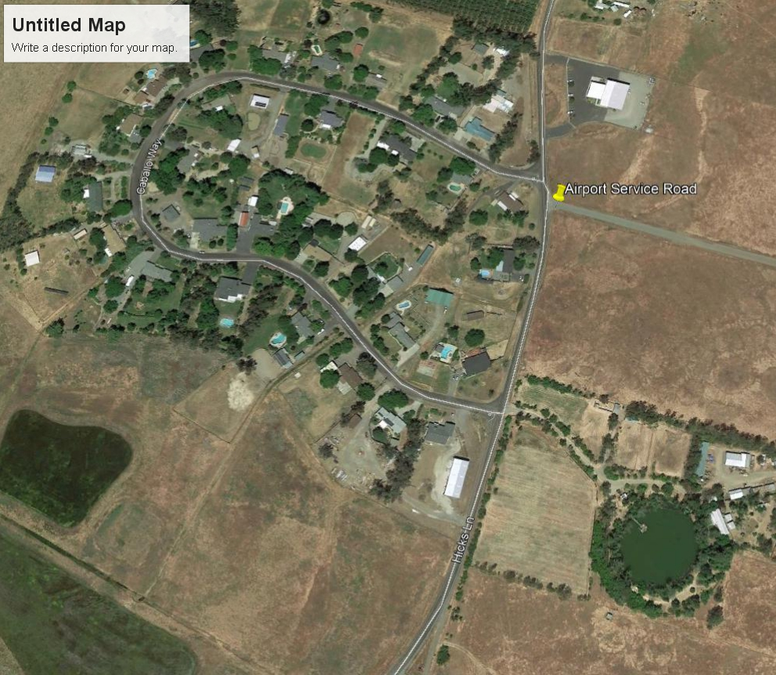

Links and documents to help prepare for your DMV pre-trip and drive test:

YouTube videos for pre-trip inspection. Both are good however they both miss a couple of different things. (Be patient, some links are slow to load)
https://www.youtube.com/watch?v=WJQ2wV11MWU (Ignore the trailer portion for class “B” only)
https://www.youtube.com/watch?v=7_LIw4XoIVU (Omit the in cab inspection and air brake test)

CA. DMV Commercial Driver Handbook:
Section 5 Air Brake and Section 11 Vehicle Inspection Test
You may print and bring with you the “CDL Vehicle Inspection Memory Aid” at the end of chapter 11 to use during the Pre-trip test without any notes written on it.
https://www.dmv.ca.gov/portal/uploads/2020/06/comlhdbk.pdf

Any questions please call me (Brian) @ (530) 521-2771

