Butte County Fire Department

Driver/Operator
Task Book

For

Squad and Rescue Operator
Circle one

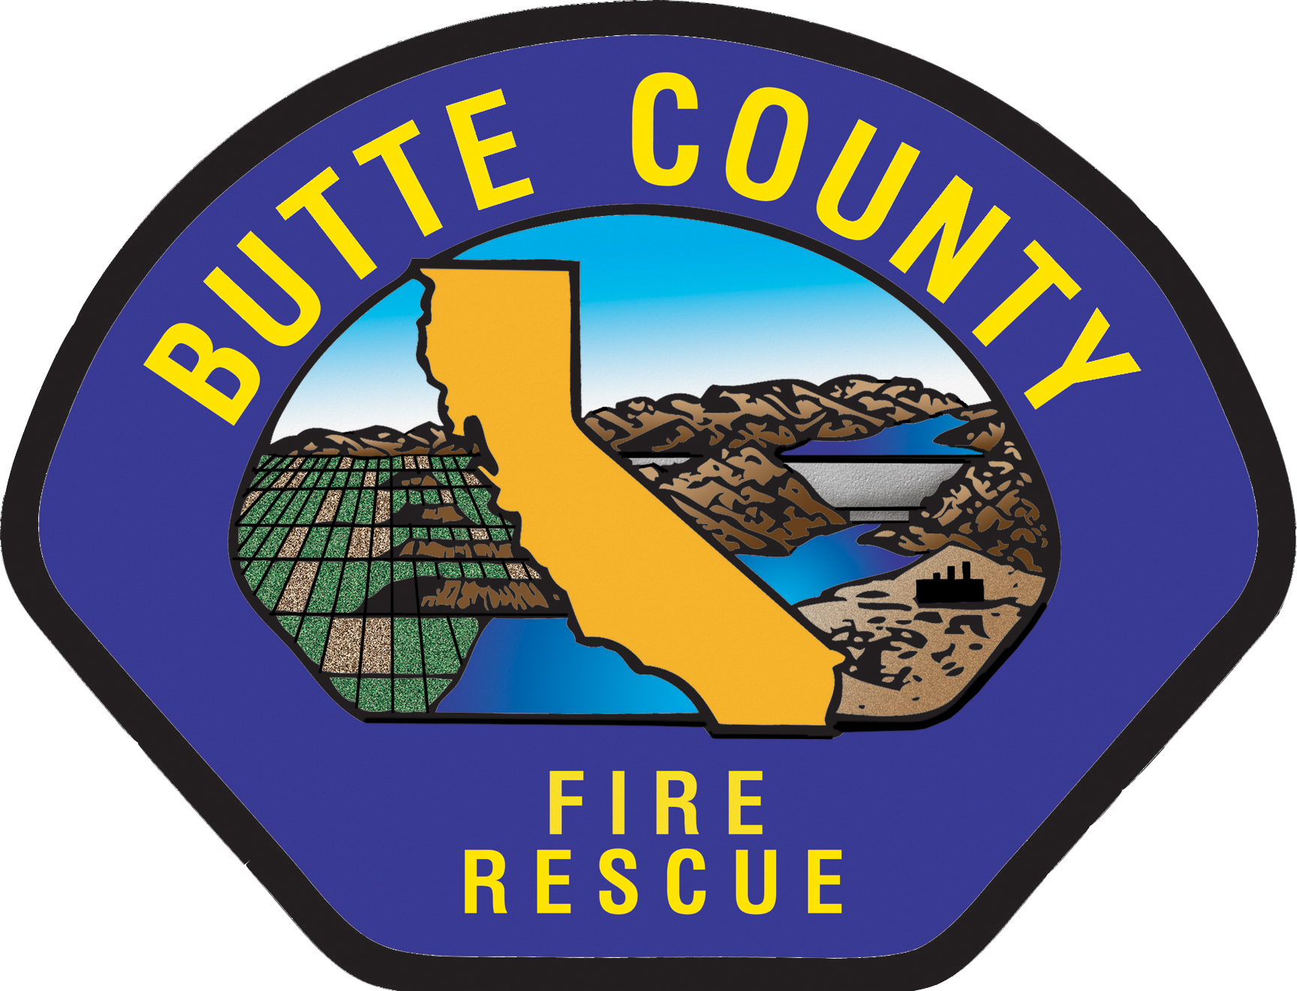
Task Book Assigned To:

Name:____________________________________________________

Volunteer Company:_____________ Start Date to VFC:____________

Task Book Initiated By:

Name:____________________________________________________
Training and Safety Bureau Chief or Designee

Date Initiated:______________________________________________

Task books can only be initiated by the Training and Safety Bureau Chief or designee after required training and classes to operate the desired department vehicle have been completed (some courses can be completed after Task Book initiation, see 5.22, Position Task Book).

TASK BOOK ASSIGNED TO:

INDIVIDUAL’S NAME AND DUTY STATION

Verification/Certification of Completed Task Book for Driver/Operator
Final Evaluator’s Verification

To be completed ONLY when you are recommending the trainee for certification.

I verify that (trainee name) ________________________________________ has successfully performed as a trainee by demonstrating all tasks for the position listed above and should be considered for certification in this position. All tasks are documented with appropriate signatures.

Volunteer Captain Signature: ______________________________Date: ________

Career Captain Signature: ________________________________ Date: ________

Battalion Chief Signature: _________________________________Date: _______

Training and Safety Bureau Approval

I certify that the above trainee has met all requirements to operate the vehicle listed on the front of this task book.

Training Bureau Chief’s Signature: _______________________Date: __________

Butte County Fire Department
Position Task Book

The Butte County Fire Department’s (BCFD) Position Task Book (PTB) has been developed for and must be completed for all Driver/Operator positions. Each PTB lists the competencies and tasks required for successful vehicle operations. VFF’s must be observed completing all tasks and show knowledge and competency in their performance during the completion of the PTB.

VFF’s are evaluated during this process by qualified evaluators (career and Volunteer), and the VFF’s performance is documented in the PTB for each task by the evaluator’s signature and date of completion.

VFF’s can only be evaluated by career company officers and/or volunteer operators/engineers qualified by BCFD to operate the vehicle the VFF is training to operate.

Task Book Initiation
Once a VFF has been a BCFD VFF in good standing for a minimum of six months and has completed all of the required training and classes to operate the desired department vehicle (some courses can be completed prior to Task Book completion, see 5.22, Position Task Book), the VFC Captain (with the concurrence of the Career Captain and Battalion Chief) can request the Training & Safety Bureau Battalion Chief to initiate and provide a Driver/Operator Task Book for the VFF.

Once the Driver/Operator Task Book has been initiated, the Task Book will be returned to the VFC Captain and the VFF can start operating department vehicles as a trainee.

VFF’s cannot drive department vehicles prior to Task Book initiation. Task Book tasks signed off prior to the Task Book being initiated by the Training & Safety Bureau Battalion Chief, are not valid.

Once the Task Book is completed and the VFC Captain and Career Captain both support the VFF operating department vehicles as an operator/engineer, the task book is sent to the respective Battalion Chief for approval. The Battalion Chief will forward the approved task book to the Training and Safety Bureau Chief for final signature and filing in the VFF’s training file.

Minimum Driver Training Requirements
All Vehicles

The below tasks are required for VFF’s to operate any Butte County Fire Department or VFC owned vehicles and must be completed prior to moving on to the specific vehicle sign off sheet.
Task | Date Completed  Or  Yes/No | Initials and Signature/Name of Person who conducted the Training (Print Clearly)
Been a Member in Good Standing with the Department for six Months. The Fire Chief may approve PVFF’s to operate department or VFC apparatus prior to the six-month probationary requirement being completed based on the VPFF’s previous organized fire department experience if all of the departments required training has been completed. Attachment 10.8, Training Equivalency Waver Form must be completed.
Completed Required Modules for Level of Response
Current on ALL Mandatory Certifications
(EMS, CPR, HazMat FRO, Etc)
Current Defensive Driver Card
Current & valid CDL with endorsements for desired vehicle
NIMS-800
Emergency Vehicle Operations Course (EVOC) 16 Hour Course (CSFM)
New Driver added to the Pull Notice Program
Daily Equipment Checkout (ME101)
Mobile Equipment Repairs (ME14)
Review State Laws related to Code 3 Driving
Review Department Driving Policies & SOP Manual for Emergency Driving
Review Department Vehicle Accident Policy and Reporting Procedures
Review Vehicle Fueling and Fuel Use Documentation Procedures
Review Preventative Maintenance Procedures (6805 Pamphlet)
Review Radio Use and Etiquette Procedures
Review Department Cell Phone Use Policy
Complete 2 Case studies of Emergency Driving Related Accidents (FEMA, NTSB, FF close calls)
Review Driver Safety While Working Freeway or Roadway Emergencies
Review Placement of Emergency Vehicles at an Emergency Scene
CODE 3 RESPONSES
VFF’s only have to complete Code-3 responses in one department or VFC vehicle if previous required code-3 responses were documented in a Driver Operator Task book

Minimum Driver Training Requirements
Squad and Rescue

The below tasks are required for VFF to operate any Butte County Fire Department or VFC owned squad/rescue vehicles and must be completed prior to operating a squad/rescue without an instructor.

Task | Date Completed  Or  Yes/No | Initials and Signature/Name of Person who conducted the Training (Print Clearly)
Submit Attachment 10.15 (Authorization to Drive) Including a Copy of Valid Class of License required to operate desired vehicle with endorsements. This form is completed and submitted after Task Book completion and final approval drive with Career Company Officer.
Completion of Support, EMS and FF Modules
Completion of Incident Management
Completion of Auto Extrication 1 (jaws only)
Completion of LARRO (rescue’s only)
Complete specialized equipment orientation
Qualified rescue operators do not need to repeat the driving portion of the task book to operate a squad.
Daily Inspection Procedures
Vehicle Interior
Vehicle Exterior
Engine Compartment (Fluid Levels)
Radiator, Hoses, Belts, Wires, Etc.
Lights, High, Low, Turn, Park, clearance, Stop, Hazard and Code 3 (solid red light)
Brakes, Drums, Brake Chamber, Hoses, Brake Lining
Steering Components
Wheels, Tires, Tread Depth, Lug Nuts, Axle Nuts
Suspension, Springs, Shackles, Shocks
Driveline and U-Joints
Batteries
Fuel Level
Fire Extinguisher & First Aid Kit
Green Folder-Accident Forms, Registration
Emergency Reflectors
Ember Protection Screens
Vehicle Inventory
In Cab Inspections
Seats, seat Belts, Loose Items, Horn, Mirrors
Windshield, Wiper Blades, Side and Rear Glass
Clutch, Accelerator & Brake Pedals
Brake System - Compressor Cut In and Out Procedures and Low Pressure Warning Gauges
Check Air Loss (engine off) – Parking Brake Applied & Released, Brakes Applied – Parking Brake Released
Check Emergency Parking Brake
Also Check
Tools, Saws & Portable Generator
Air Brake Inspection
Perform the Below Skills
Pre-Trip Inspection
Winching
Vehicle Operations
Golden Circle (prior to moving vehicle)
Bridge Weight verses Vehicle Weight
Vehicle Clearance Height
Vehicle Performance – Engine Horse Power, Transmission Operation and Braking System
Towing/Being Towed
Spotting Apparatus – Staging, Using as a Shield (T/C’s), Structure Fire Operations
Off Road Driving
Walk Path to determine Location of Rocks, Brush, Soil Conditions and Slope %
Transmission in 1st Gear Until Level Ground is Reached
Vehicle Can Not Coast
No Side Slope that Exceeds Safe Vehicle Operations
Vehicle Inspection Prior to driving on Highway – Rock in Duels, Vehicle Damage, Loose equipment, Open compartments
Competency Driving
Complete 8 hours of Documented Code-2 Day Time Driving with Proctor (2 hours city driving, 2 hours highway driving and 4 hours narrow county road driving (Must Log Hours on Attached Driving Log)
Complete 2 Hours of Documented Code-2 Night Time Driving with Proctor
(Must Log Hours on Attached Driving Log)
Complete 2 Hours of Documented Code-2 Off Road Driving with Proctor (Must Log Hours on Attached Driving Log)
Complete 3 Code-3 Responses with a proctor (Must Log Responses on attached Driving
Log). See page 4 for additional information.
Passing Proficiency Skills Drive (Drive with Evaluator) (Must Fill Out Evaluation Form)

Drivers Log
All Vehicles

CATEGORY  Day/Night, On/Off Road  Code 3 | Date | TOTAL TIME  (hr/Min) | Initials or Signature & printed Name of Person who conducted the Training (Print Clearly) | PROFICIENT  Y\N
Drivers Log
All Vehicles

CATEGORY  Day/Night, On/Off Road  Code 3 | Date |  | TOTAL TIME  (hr/Min) | Initials or Signature & printed Name of Person who conducted the Training (Print Clearly) | PROFICIENT  Y\N
CATEGORY |  | COMMENTS  (INSTRUCTOR PLEASE INITIAL COMMENTS)

On Highway Driving
Skills Test | Good | Acceptable Improvement  Needed | Poor | Fail
Caution  1. At intersections  2. Changing Lanes  3. Pulling from the curb | 10 | 3 | 0
Grade Control  1. Roll back  2. Setting Wheels and Controls  3. Driving Upgrade/Downgrade | 10 | 7 | 5
Traffic Signs  1. Obedience to Traffic Signs  2. Position after stopping  3. Failure to make full stop | 10 | 7 | 3
Right and Left Turns  1. Swings Too Wide  2. Cuts Too Sharp  3. Starting lane position  4. Ending lane position | 10 | 7 | 3
Right of Way  1. To other vehicles/pedestrians | 10 | 5 | 0
Speed Control  1. Over Speed  2. Under Speed  3. Adjusted for conditions | 10 | 5 | 2
Lane Control  1. Maintain proper position  2. Right side remains on pavement | 10 | 7 | 3
Braking  1 Proper technique & application  2 Proper use of dynamic brake  3 Protect against overheating | 10 | 7 | 3

Total Points Possible: 80 (61 Passing) Total Points Scored: ________

EVALUATOR’S SIGNATURE:__________________________ Date:

Off Highway Driving
Skills Test | Good | Acceptable Improvement  Needed | Poor | Fail
- Places vehicle in rear tandem lock  - Returns to single axle drive prior to returning to hard road surface | 10 | 3 | 0
- Goes through a Go/No-Go check list before attempting any potentially challenging terrain. | 10 | 7 | 5
- Determines a path including turning points prior to entering sharp turns  - Keeps vehicle as level as possible  - Keeps wheels in position for maximum traction | 10 | 7 | 3
Gullies & Ditches:  - Scout first if uncertain  - Easy in / power out  - Uses a spotter  - Straddles V grove when possible | 10 | 7 | 3
Side Hill:  - Articulate vehicle limitations on side hill  - Avoid whenever possible  - Avoid stumps & rocks on uphill side  - Watch for down hill holes  - Use a spotter if in doubt | 10 | 5 | 0
Ascending & Descending Hills  - Turnaround top/bottom of hill  - Estimate slope  - Maintains rolling friction/traction  - Minimal power up hill/ minimal speed down hill  - Restarting on a hill | 10 | 5 | 2
- Use of spray bars  - Avoids vegetation that could damage engine  - Post trip inspection | 10 | 7 | 3
Total Points Possible: 70 (61 Passing) Total Points Scored: ________

EVALUATOR’S SIGNATURE:__________________________ Date:

